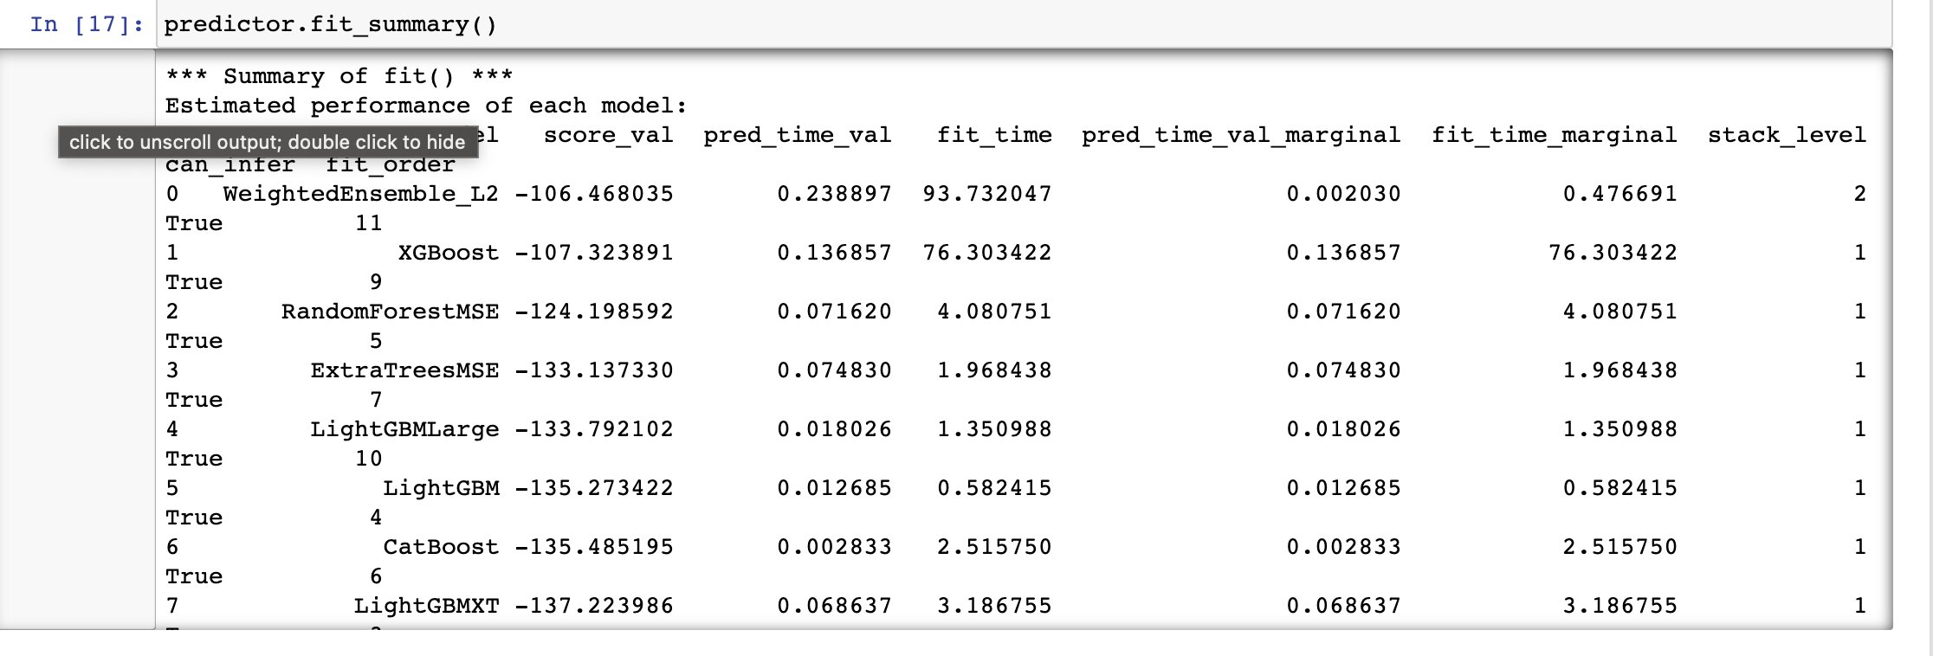

Fig. 1: Model Performance using Autogluon default hyperparameters and models

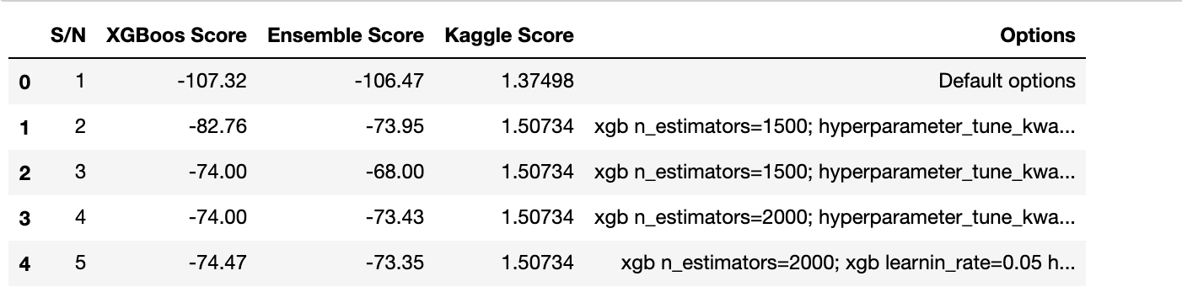

Fig.2: Various Hyperparamer(option) sets and the corresponding models performances and Kaggle scores